Sunshine Smoothie Bowl with Golden Glow
☀️🥭🥥

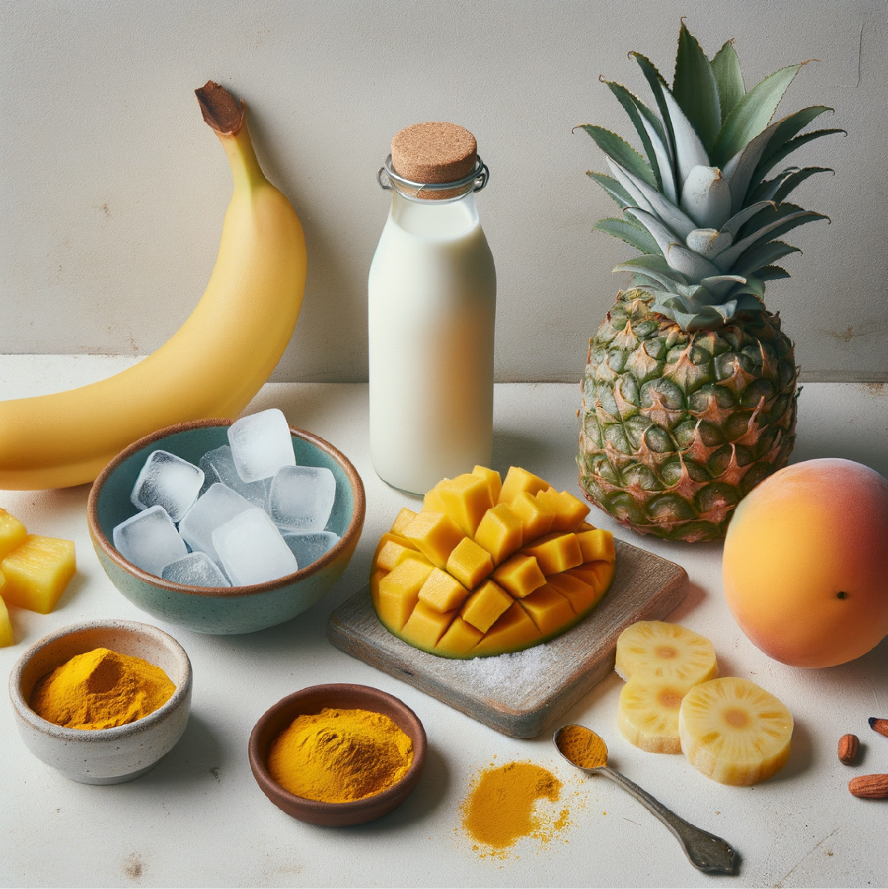
🥬 Ingredients
- 1 frozen banana
- ½ cup frozen mango chunks
- ½ cup fresh pineapple
- 1 teaspoon ground turmeric
- 1 cup unsweetened coconut milk
- Toppings: sliced kiwi, shredded coconut, pumpkin seeds, goji berries

Step-by-Step Instructions
1. Prepare your ingredients
- Peel and freeze your banana ahead of time for a thick, creamy texture.
- Measure out mango chunks and slice fresh pineapple into small cubes.
- Have toppings ready in small bowls — this makes decorating easier and more fun.
2. Blend the base
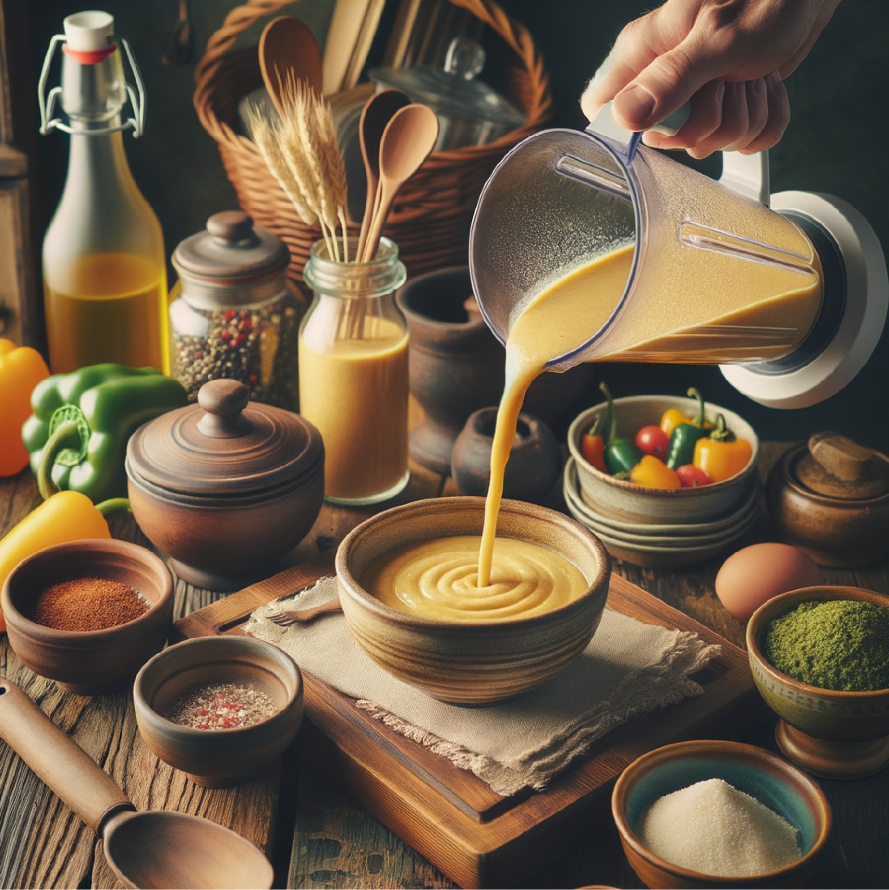
- In a high-speed blender, add frozen banana, frozen mango, fresh pineapple, turmeric, and coconut milk.
- Blend on low to medium speed, using a tamper if needed, until the mixture is thick and smooth — think soft-serve consistency.
3. Adjust texture if needed
- If it’s too thick to blend, add a splash more coconut milk.
- If it’s too runny, add a few extra frozen mango chunks.
4. Pour & decorate
- Pour the golden smoothie into a bowl.
- Arrange toppings in neat rows or creative clusters: kiwi slices, shredded coconut, pumpkin seeds, and goji berries.
- Snap a photo — this bowl is pure tropical sunshine in edible form.
5. Serve immediately
- Enjoy with a spoon and soak up that golden glow!
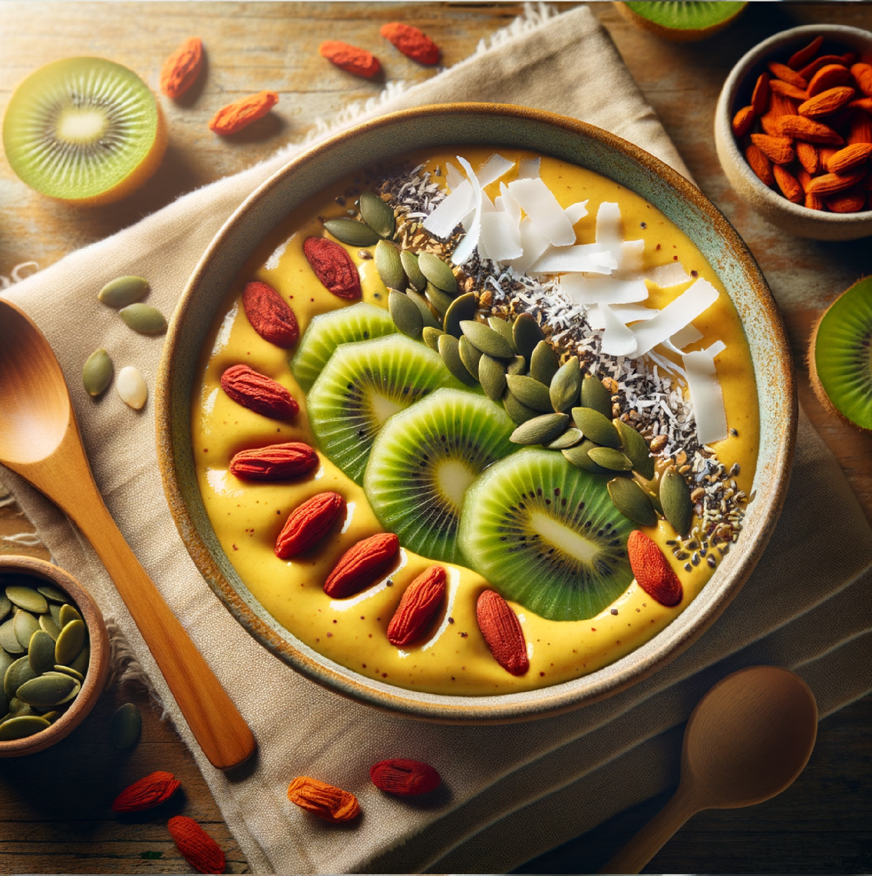

Fun Facts ☀️
- Turmeric’s golden color comes from curcumin, a powerful antioxidant with anti-inflammatory benefits.
- Mango is called the "king of fruits" in many cultures and is packed with vitamins A and C for glowing skin.
- Pineapple contains bromelain, an enzyme that can help with digestion.
- Goji berries have been used in Chinese medicine for centuries to boost immunity and vitality.
- This bowl’s colors aren’t just pretty — the vibrant yellow from turmeric and bright toppings signal a rainbow of nutrients.

Daily Quote 🌼
"Let the sunshine in — especially at breakfast." — Unknown

Serving Size | I bowl
Calories | 280
Protein | 4g
Carbs | 45g
Dietary Fiber | 6g
Sugars | 30g
Fat | 7g
Saturated Fat | 3g
Vitamin C | 120%
Iron | 1.5mg

