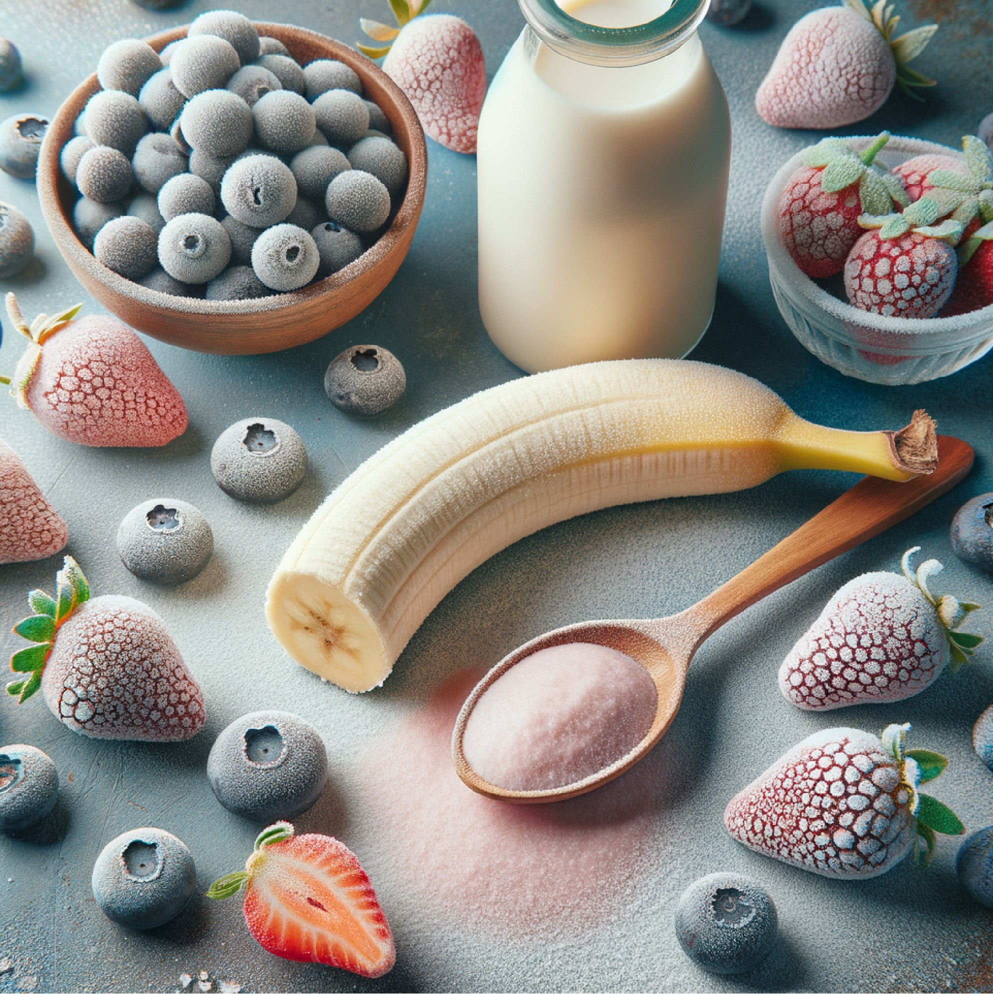
Berry Woke Smoothie Bowl 🍓🥥
(Plus, Waffle/Pancake Remix)

Berry Woke Smoothie Bowl
- ½ frozen banana
- ½ cup frozen blueberries
- ½ cup frozen strawberries
- ½ cup plant milk
- 1 scoop vegan protein powder (optional)
- Toppings: granola, chia seeds, hemp seeds, sliced fruit, shredded coconut

Toppings:
Granola, chia, hemp seeds, sliced fruit, shredded coconut
Instructions:
Detailed Instructions
For the Smoothie Bowl
- Prep your ingredients
  - ½ frozen banana
  - ½ cup frozen blueberries
  - ½ cup frozen strawberries
  - ½ cup plant milk (almond, oat, soy, etc.)
  - 1 scoop vegan protein powder (optional for extra staying power)
- Blend until thick
  - Add everything to a high-speed blender.
  - Blend on low, pushing down with a tamper if needed.
  - You’re aiming for a soft-serve ice cream consistency, not runny smoothie texture.
- Pour & decorate
  - Pour the thick mixture into a bowl.
  - Arrange toppings in pretty rows or clusters: granola, sliced fruit, chia seeds, hemp seeds, shredded coconut.
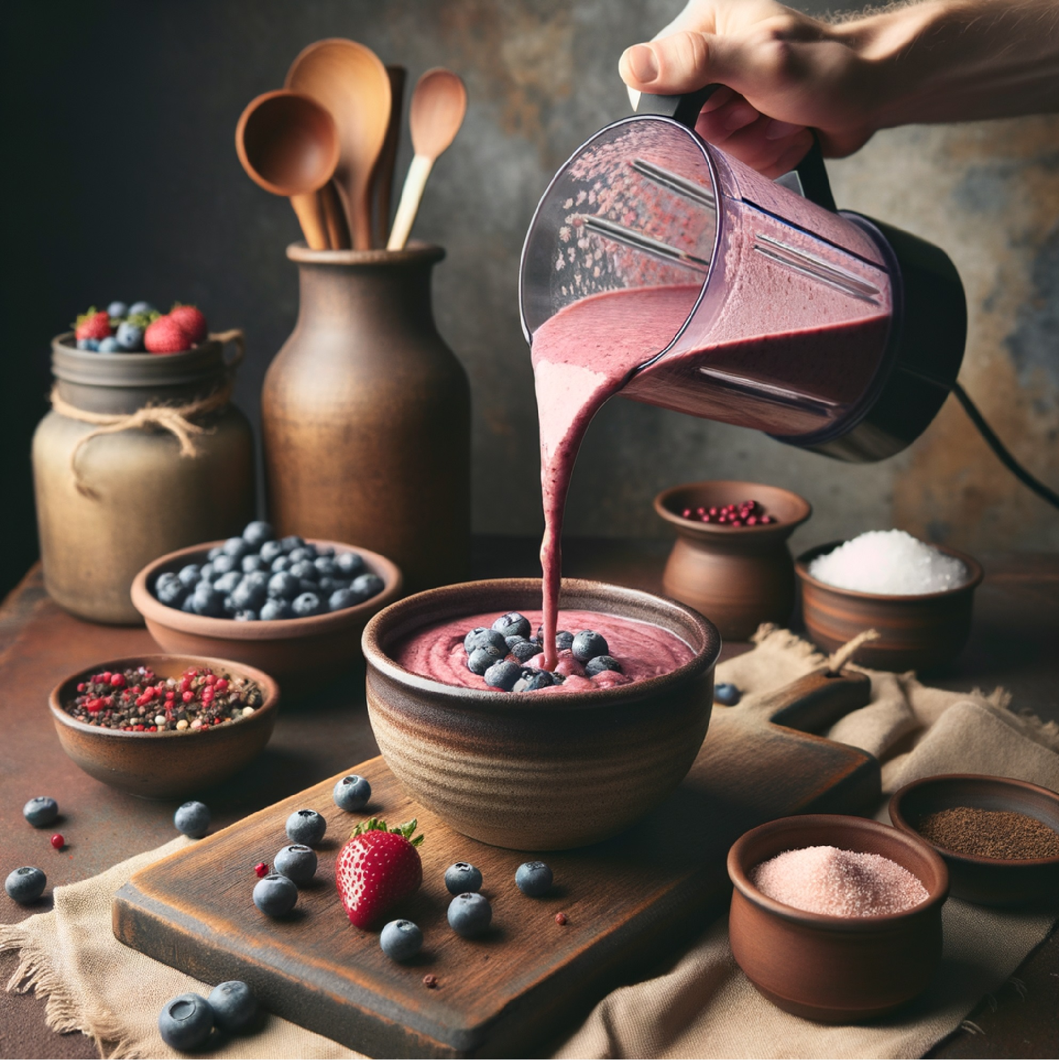
  - Snap a photo for Instagram before digging in — because you’ll want to remember this moment.
For the Waffle/Pancake Remix
- Use the same base
  - Blend the smoothie ingredients just as above but add an extra ¼ cup plant milk to make the batter slightly thinner.
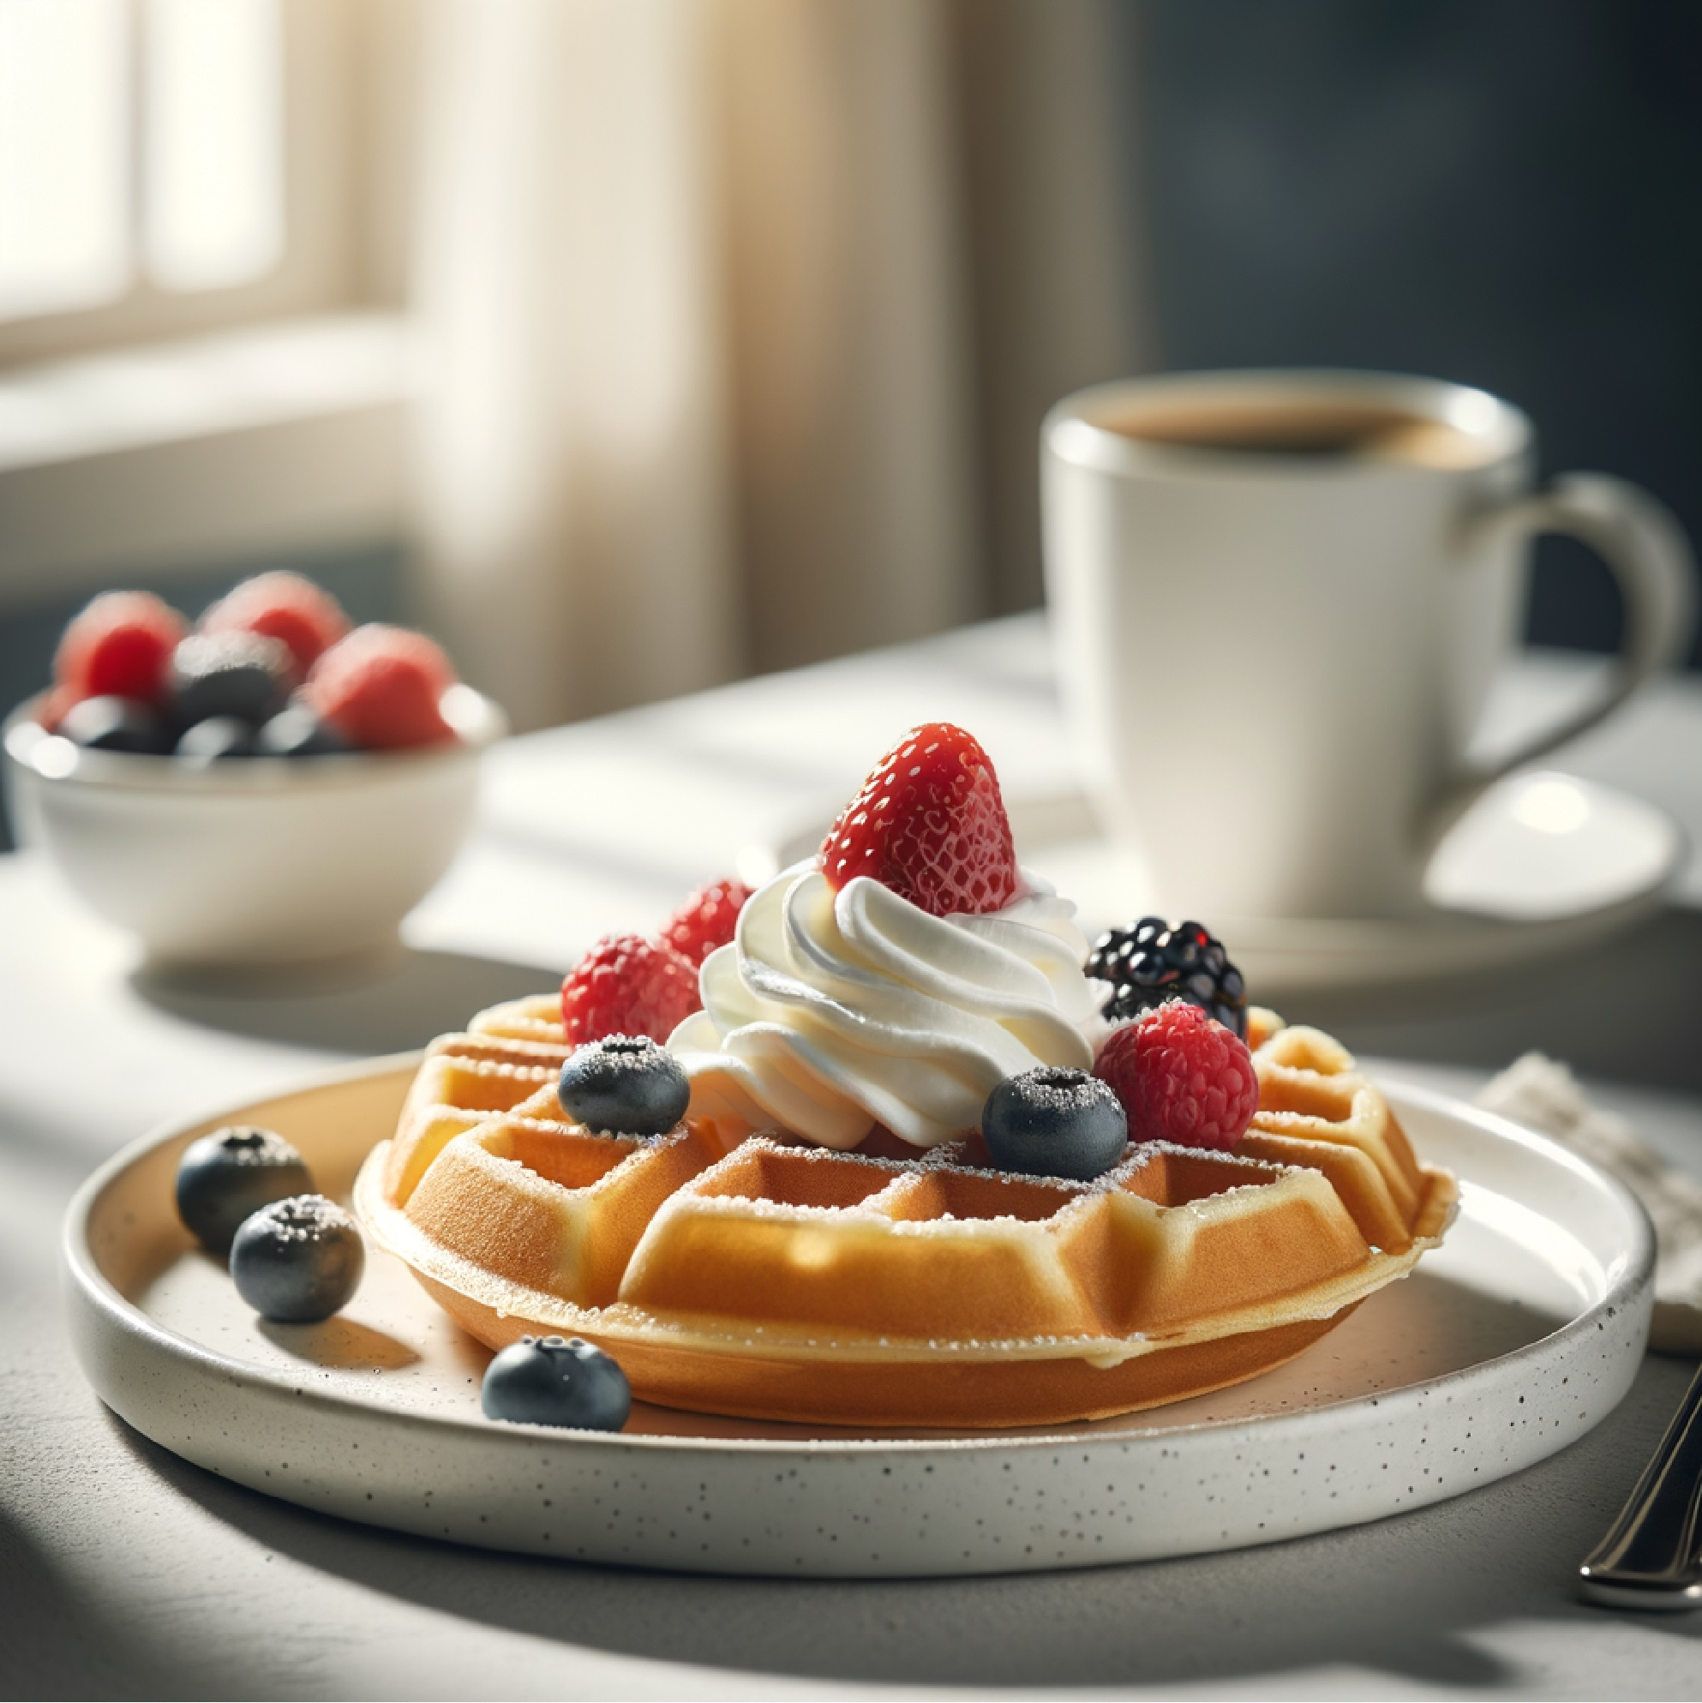
- Waffle version
  - Preheat your waffle iron.
  - Grease lightly with coconut oil or spray.
  - Pour in the batter and cook until golden and crisp on the outside.
♻️ No waffle maker? Make pancakes instead.
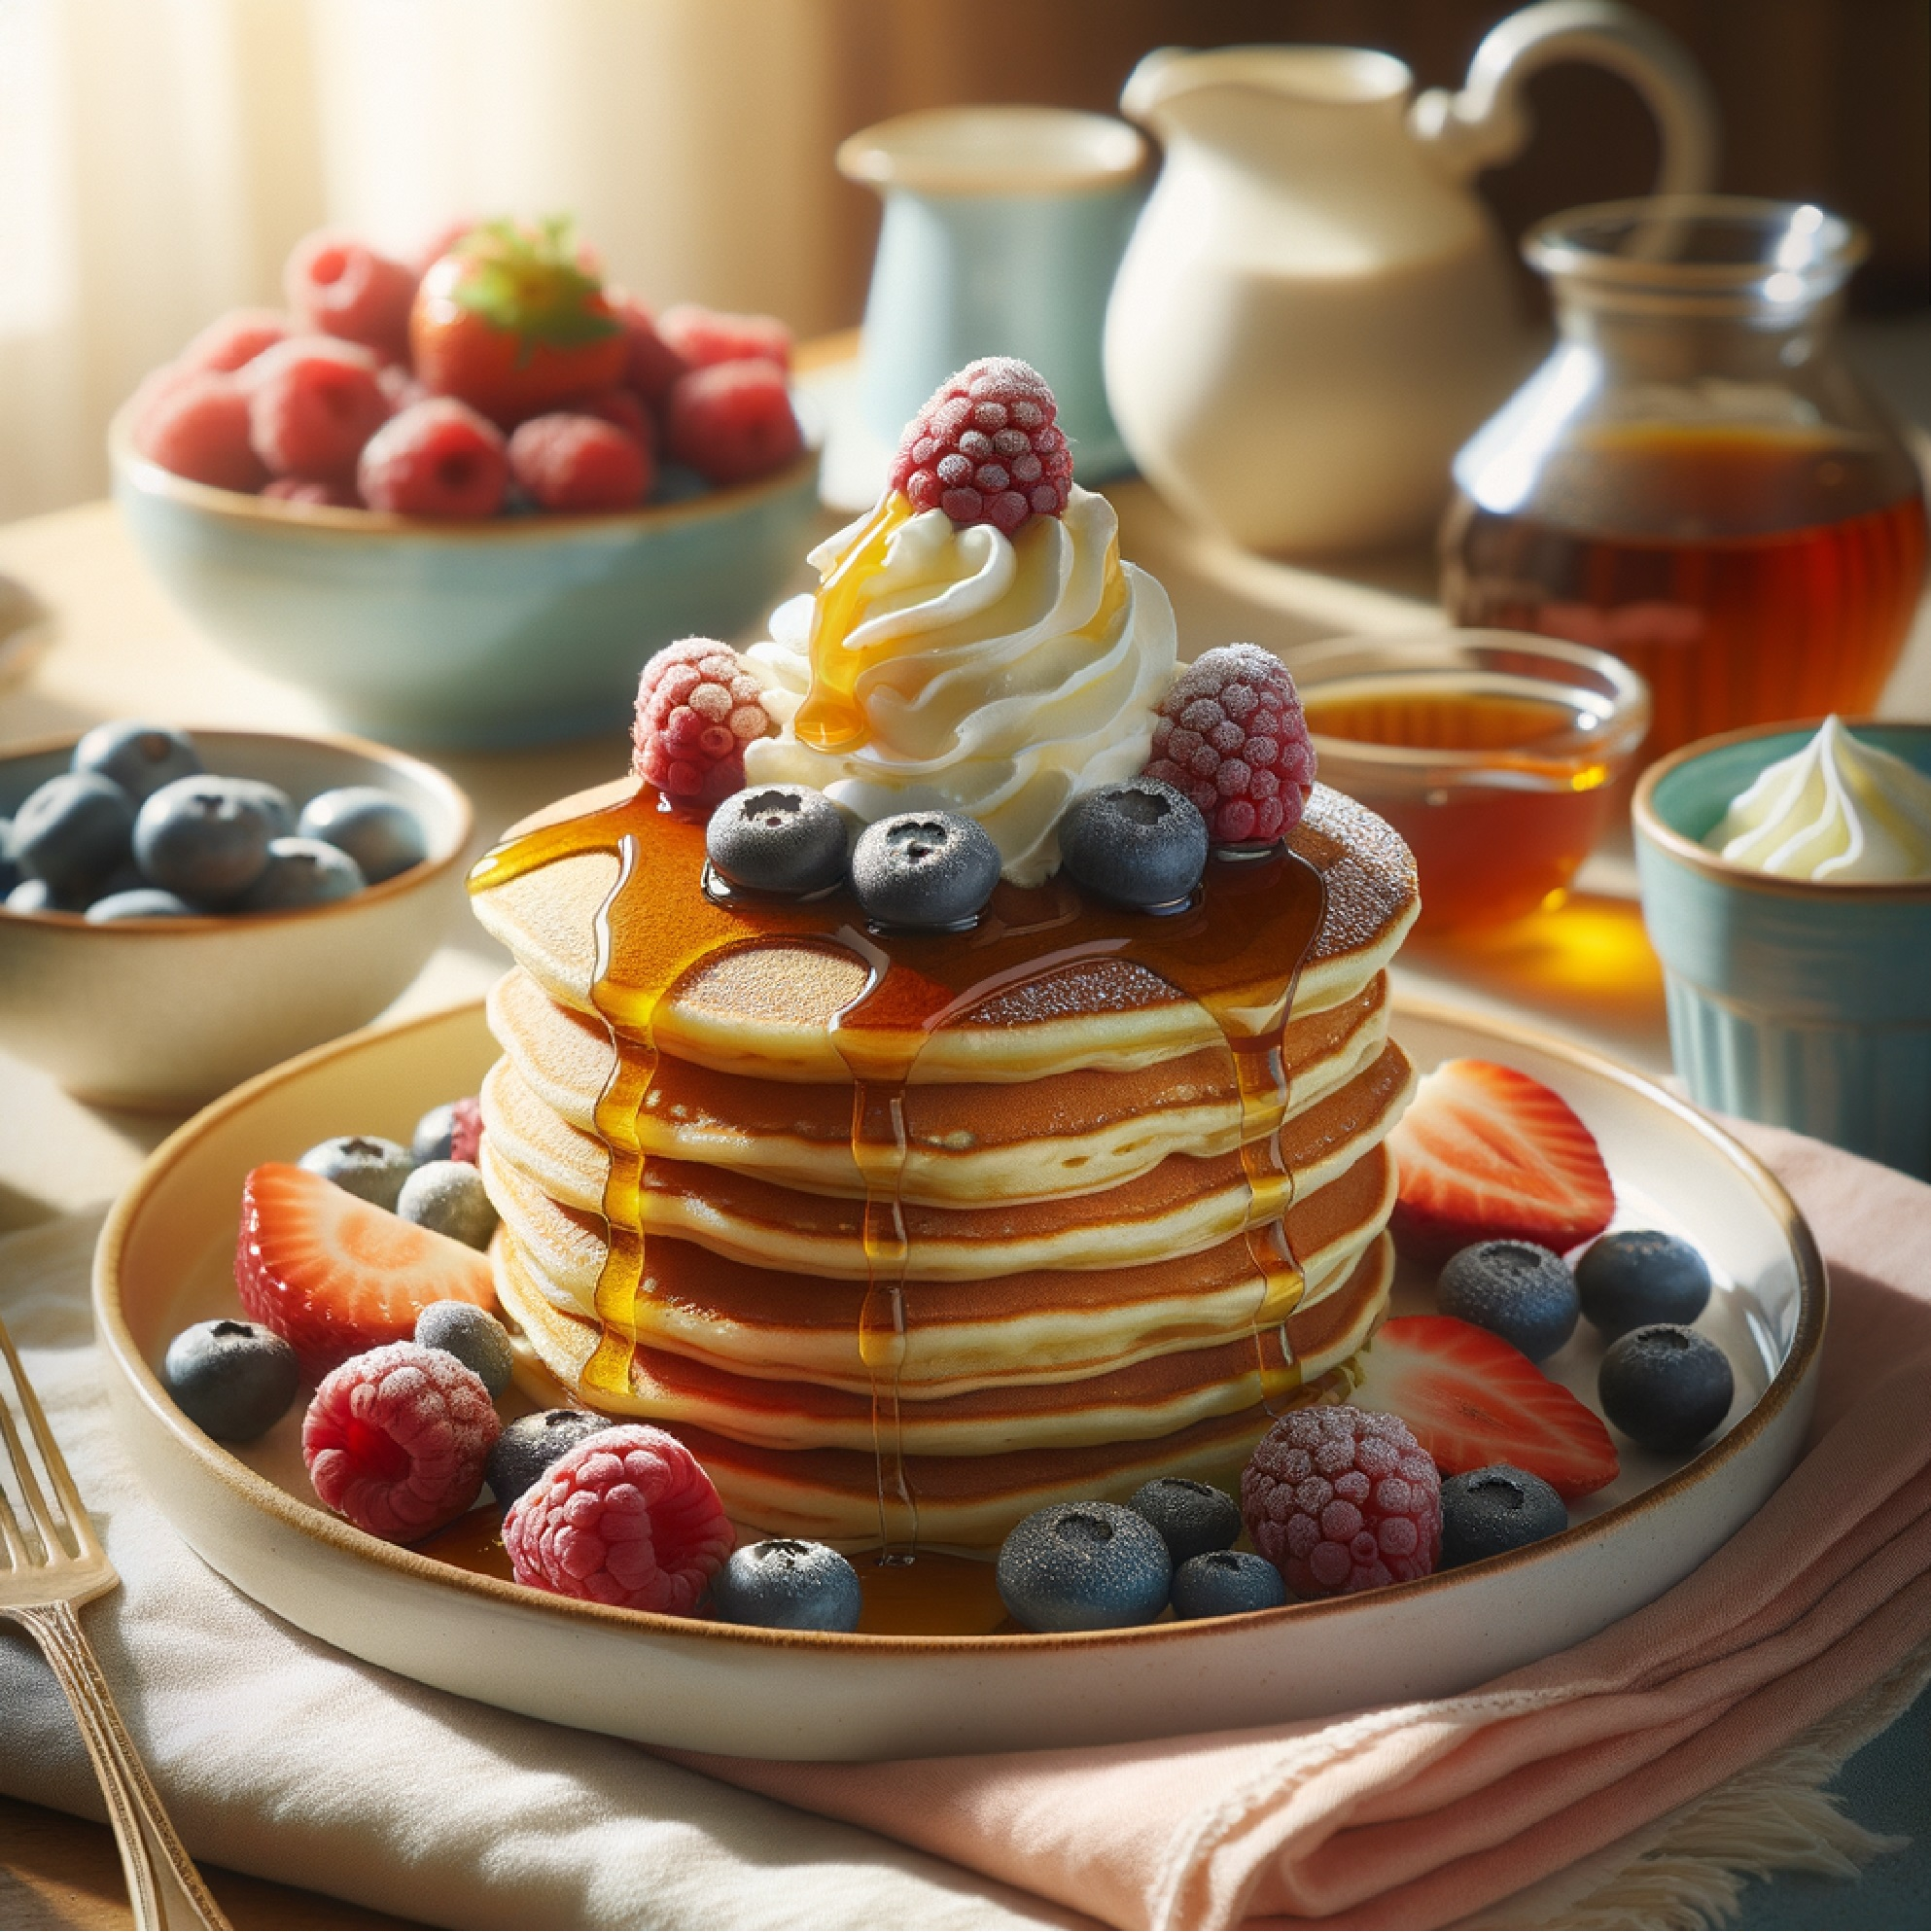
- Pancake version
  - Heat a non-stick skillet over medium heat.
  - Lightly oil, then pour batter in small circles.
  - Cook until bubbles form on top, flip, and cook until golden.
- Top it off
  - Use the same toppings as the smoothie bowl: berries, banana slices, granola, coconut, drizzle of maple syrup.

Fun Facts
- Blueberries are brain food — they’re rich in antioxidants that can help improve memory and focus. Perfect way to start the day sharp.
- Bananas are nature’s sweetener — they add creaminess and sweetness without refined sugar.
- Chia seeds are hydrating — they absorb up to 10× their weight in water, which helps you feel fuller longer.
- The smoothie bowl trend started in Brazil with açaí bowls and became a global breakfast phenomenon.
- You can make smoothie pancakes/waffles by simply adding the same blended fruit mixture into a hot waffle iron or skillet — no extra fuss!

Daily Quote
"Eat food that loves you back." — Anonymous

