Mushroom Stroganoff Seduction

Ingredients:
- 12 oz whole wheat pasta
- 1 lb mixed mushrooms, sliced
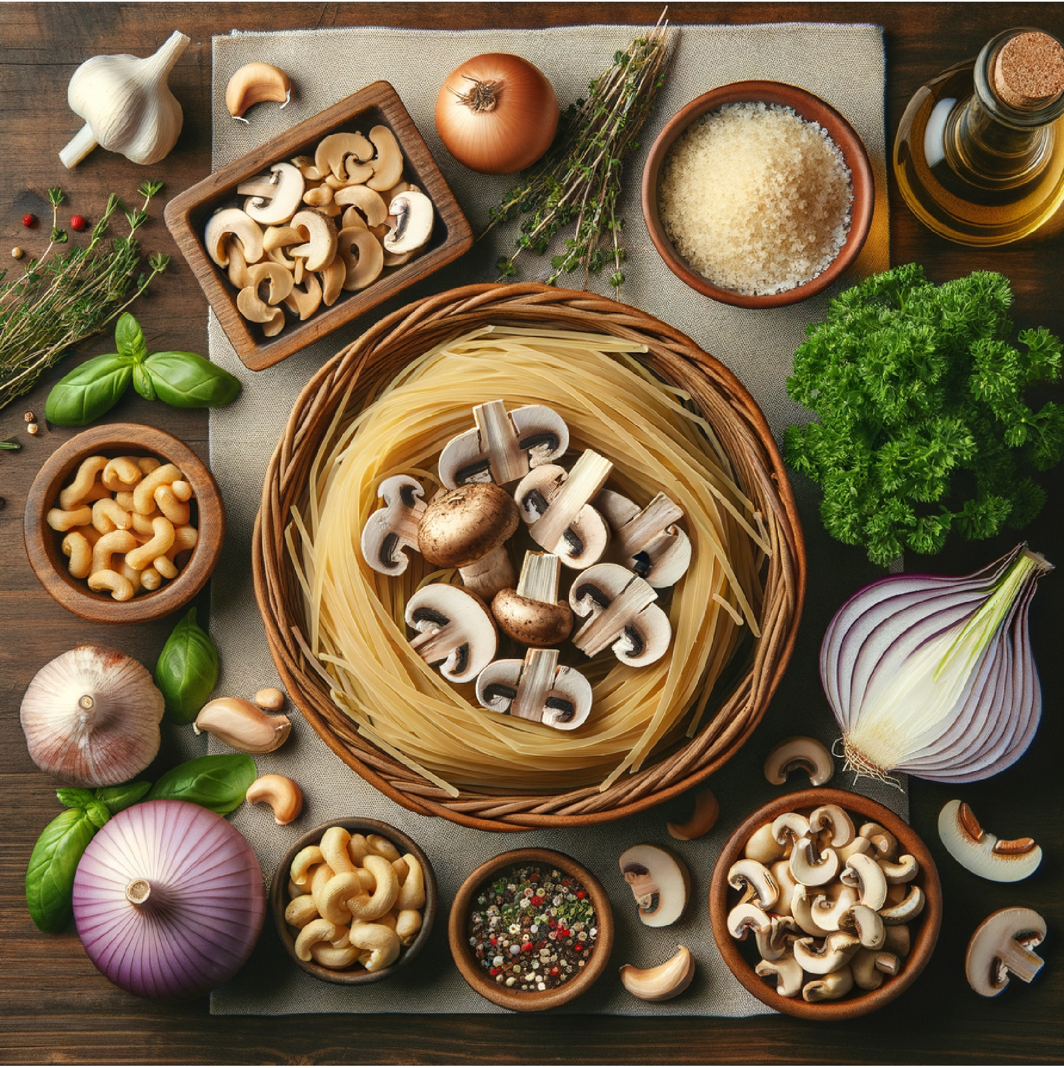
- 1 onion, diced
- 4 cloves garlic, minced
- 1 cup cashews, soaked
- 2 cups vegetable broth
- 1/4 cup nutritional yeast
- 2 tbsp tamari
- 2 tbsp white wine vinegar
- 1 tbsp dijon mustard
- 1 tsp smoked paprika
- Fresh thyme and parsley
- Salt and pepper to taste

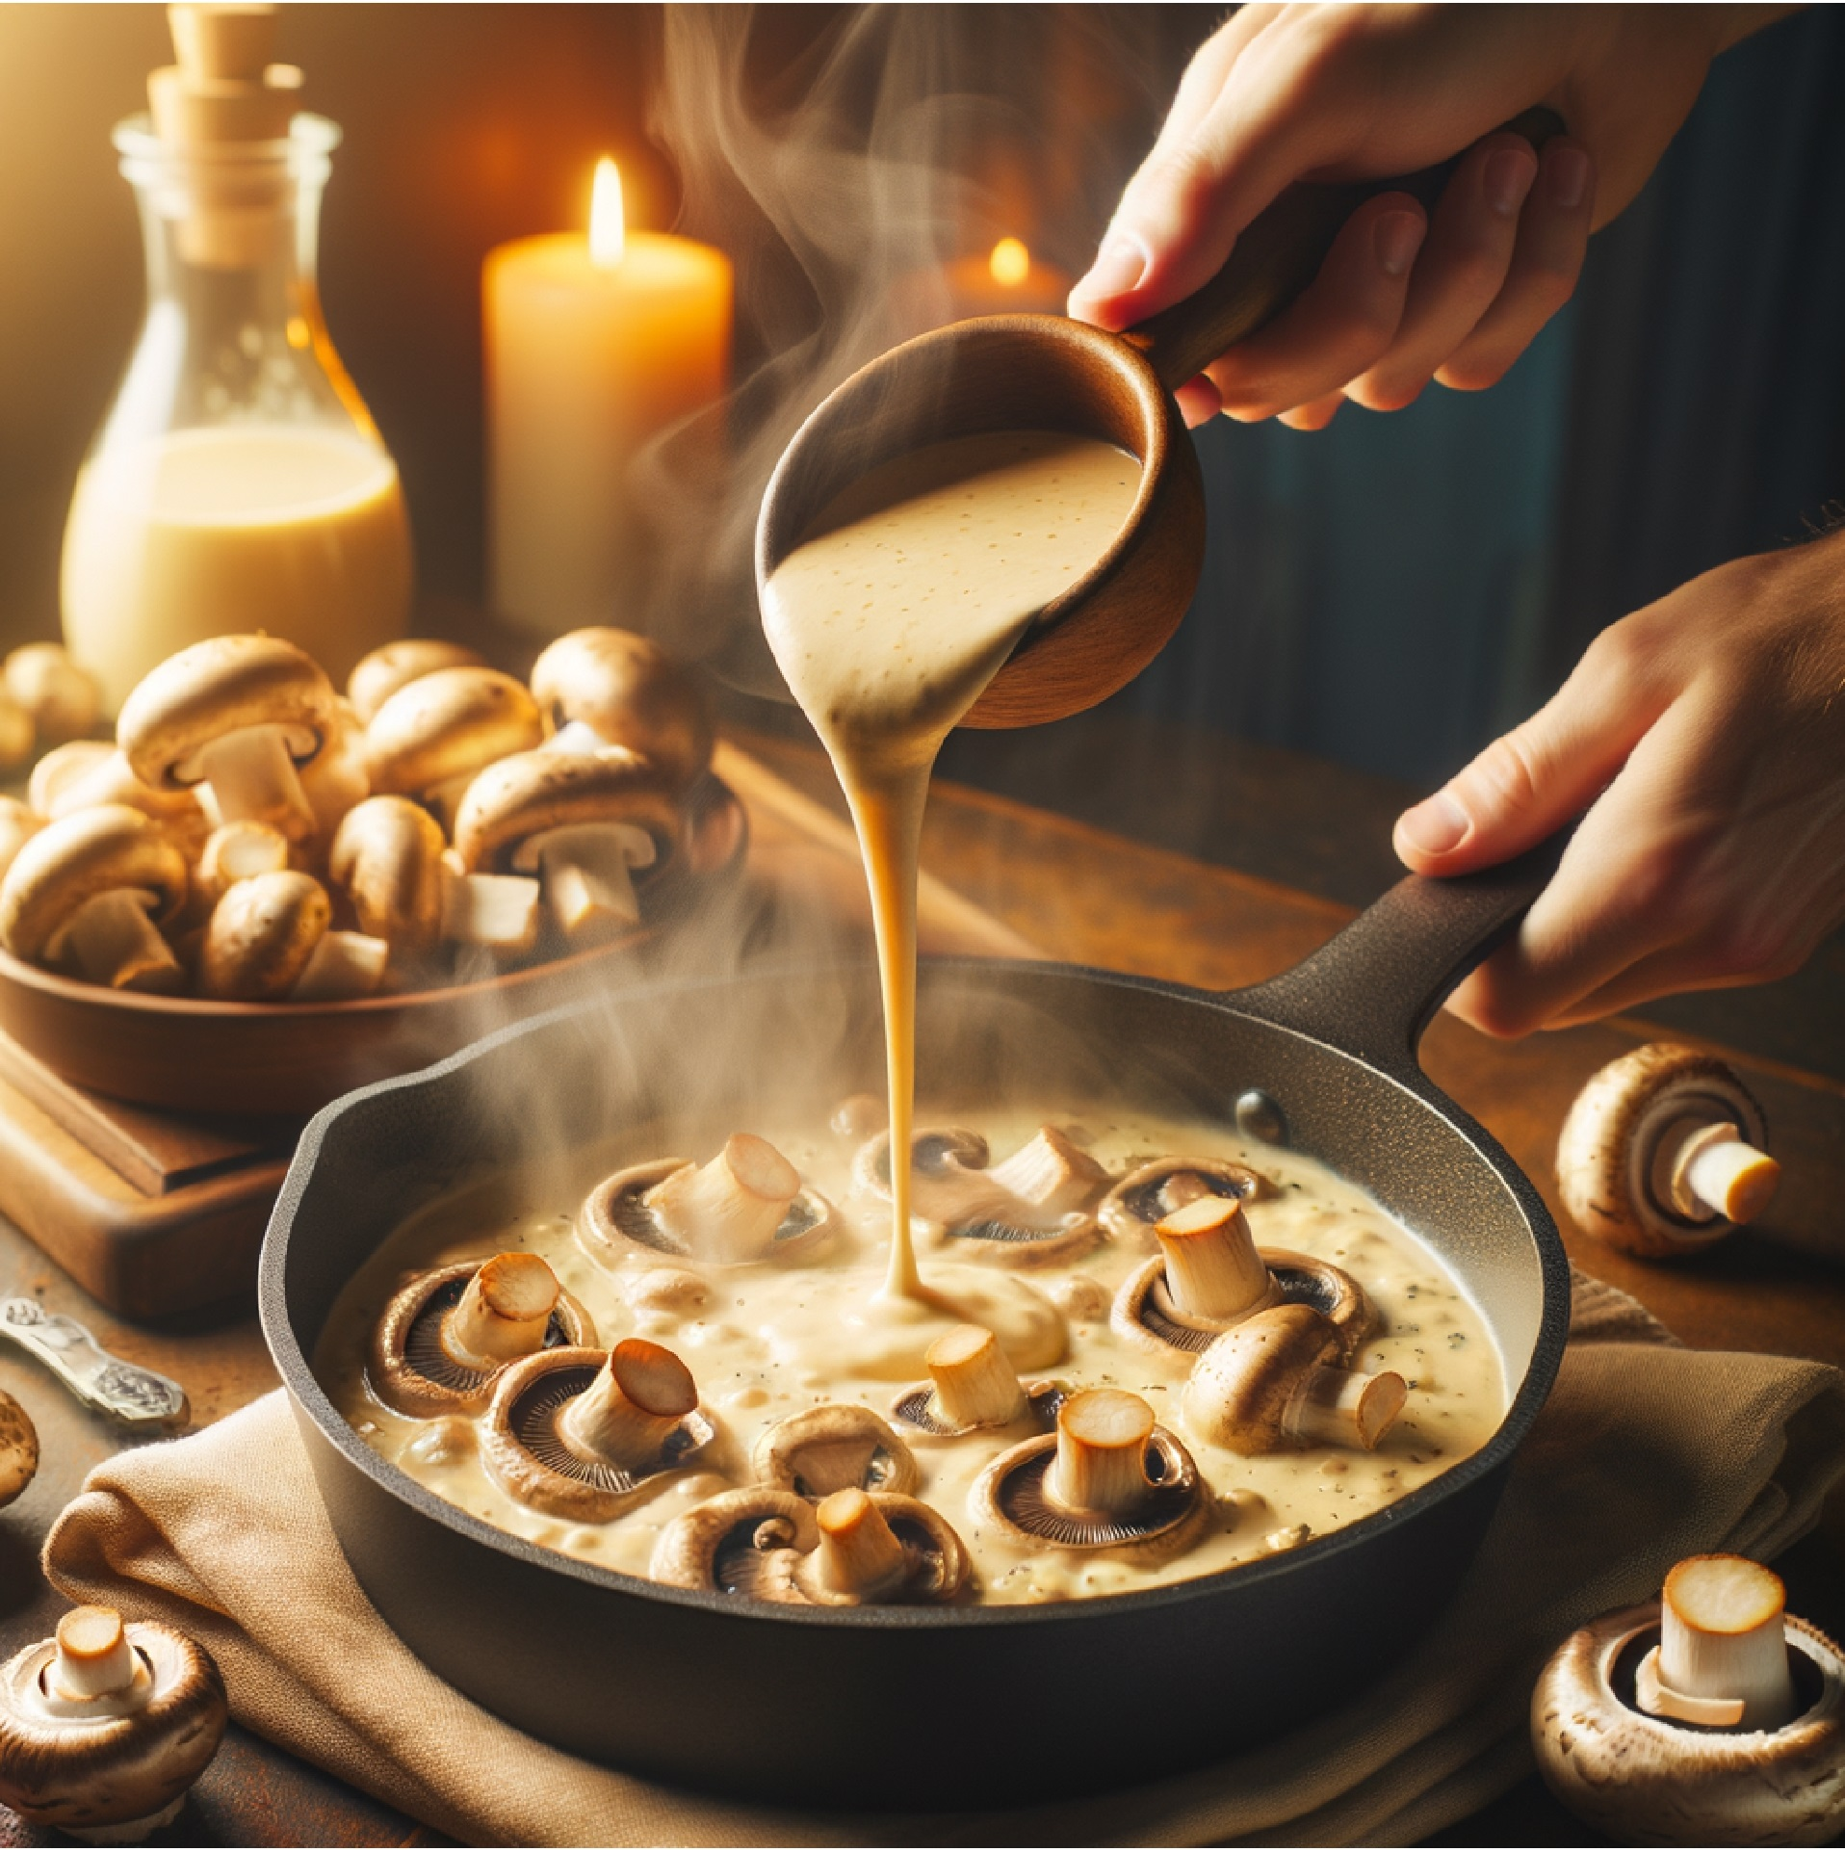
Instructions:
1. Cook the pasta
- Bring a large pot of salted water to a boil.
- Cook pasta according to package directions until al dente.
- Drain, toss lightly with olive oil to prevent sticking, and set aside.
2. Sauté the mushrooms
- Heat a large skillet over medium-high heat.
- Add a splash of olive oil.
- Once hot, add sliced mushrooms in a single layer — don’t overcrowd (work in batches if needed).
- Let them sear undisturbed for 3–4 minutes before stirring. This caramelizes them and deepens flavor.
- Stir occasionally until golden-brown, about 8–10 minutes total.
3. Add onion and garlic
- Reduce heat to medium.
- Add diced onion to the mushrooms and cook until softened, about 4–5 minutes.
- Add minced garlic and cook for 1 more minute until fragrant.
4. Make the cashew cream
- In a blender, combine soaked cashews with 1 cup of vegetable broth.
- Blend on high until completely smooth and creamy (no grainy bits).
5. Build the sauce
- Pour the cashew cream into the mushroom mixture.
- Add the remaining 1 cup broth, nutritional yeast, tamari, white wine vinegar, Dijon mustard, smoked paprika, salt, and pepper.
- Stir well to combine.
6. Simmer to thicken
- Reduce heat to low and let the sauce simmer gently for 5–7 minutes, stirring occasionally, until thickened and rich.
- Taste and adjust seasonings if needed — add more tamari for saltiness, vinegar for tang, or paprika for smokiness.
7. Toss with pasta
- Add the cooked pasta directly to the skillet with the sauce.
- Toss well until every strand is coated in creamy goodness.
8. Garnish and serve
- Sprinkle fresh thyme and parsley on top.
- Serve immediately, with extra nutritional yeast for a cheesy boost.
♻️ Substitutions: Use coconut cream instead of cashews, try different mushroom varieties, or add roasted vegetables for extra nutrition.

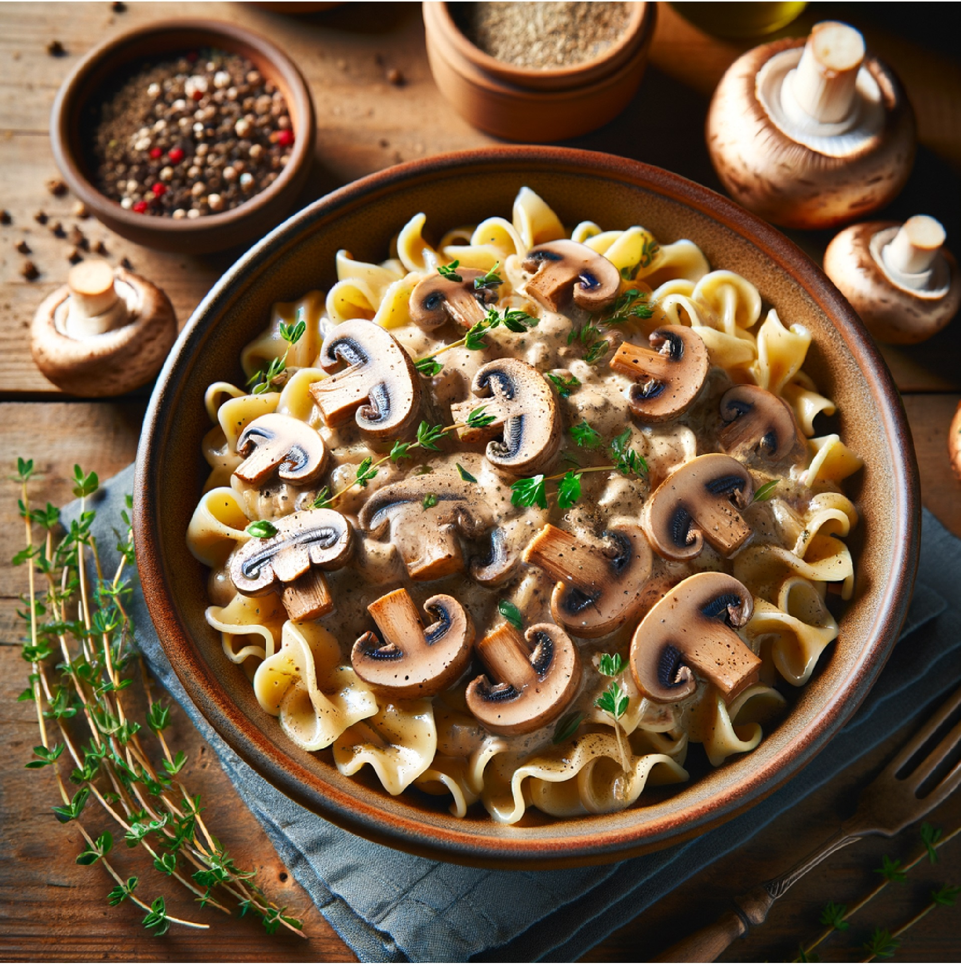
- 🧠 Umami Science: Mushrooms contain natural glutamates that create the savory "fifth taste" of umami. This makes them perfect for creating deeply satisfying, meaty flavors in plant-based dishes.
- ✍️ Comfort Food Revelation: This dish converted my most skeptical carnivore friends. The mushrooms provide that meaty umami flavor while the cashew cream creates the richest, most indulgent sauce you've ever tasted. It's proof that plant-based comfort food can be even better than the original.

"Life is too important to be taken seriously." - Oscar Wilde

Nutrient | Amount | % Daily Value*
Calories | 485 kcal | —
Protein | 20 g | —
Carbohydrates | 72 g | —
Fat | 16 g | —
Fiber | 8 g | —
Selenium | — | 45% DV
B-Vitamins | — | 25% DV (avg)
Zinc | — | 20% DV

