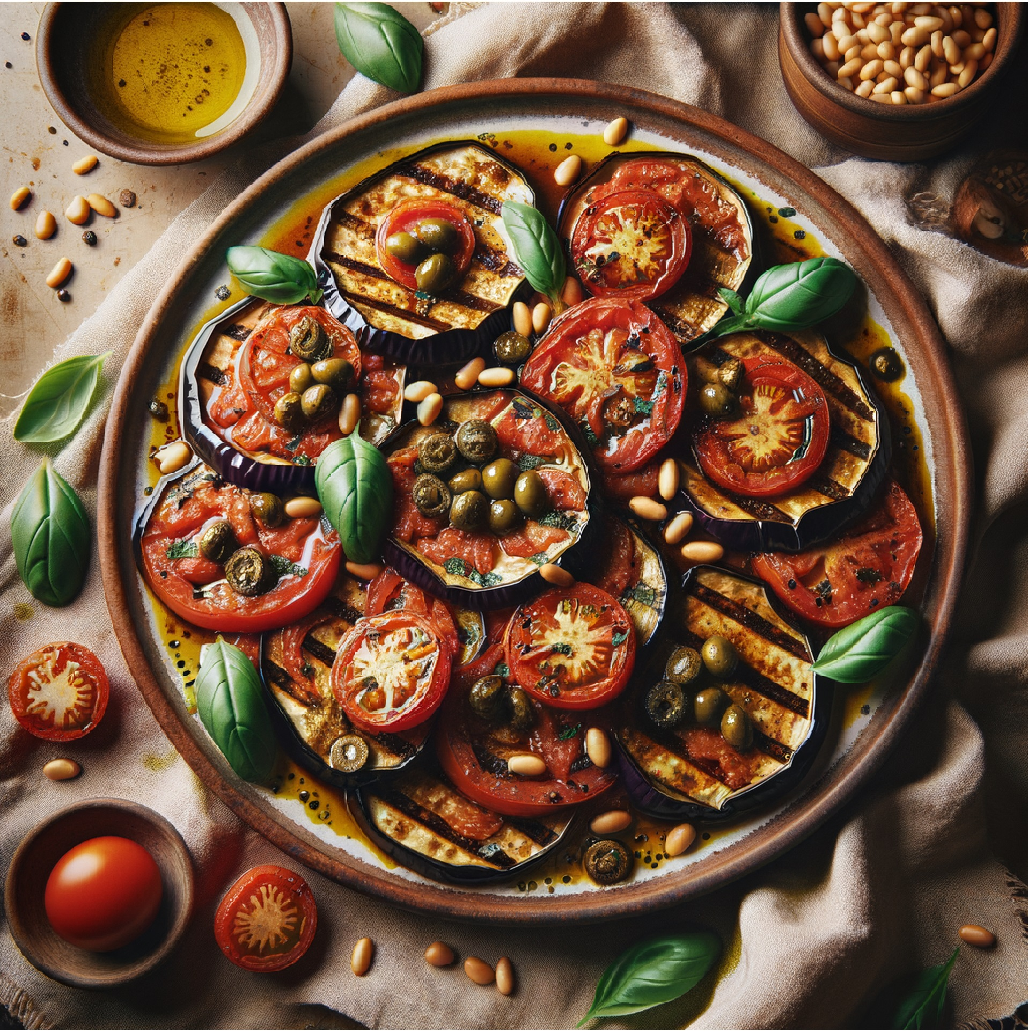
Mediterranean Eggplant Spectacular
💬 "One cannot think well, love well, sleep well, if one has not dined well." - Virginia Woolf

✍️ Mediterranean Magic: This dish embodies the spirit of the Mediterranean….fresh, vibrant, and full of life. The eggplant becomes silky and luxurious while the herbs and olive oil create a symphony of flavors.

Detailed Step-by-Step Instructions
Ingredients
- 2 large eggplants, sliced into ½-inch rounds
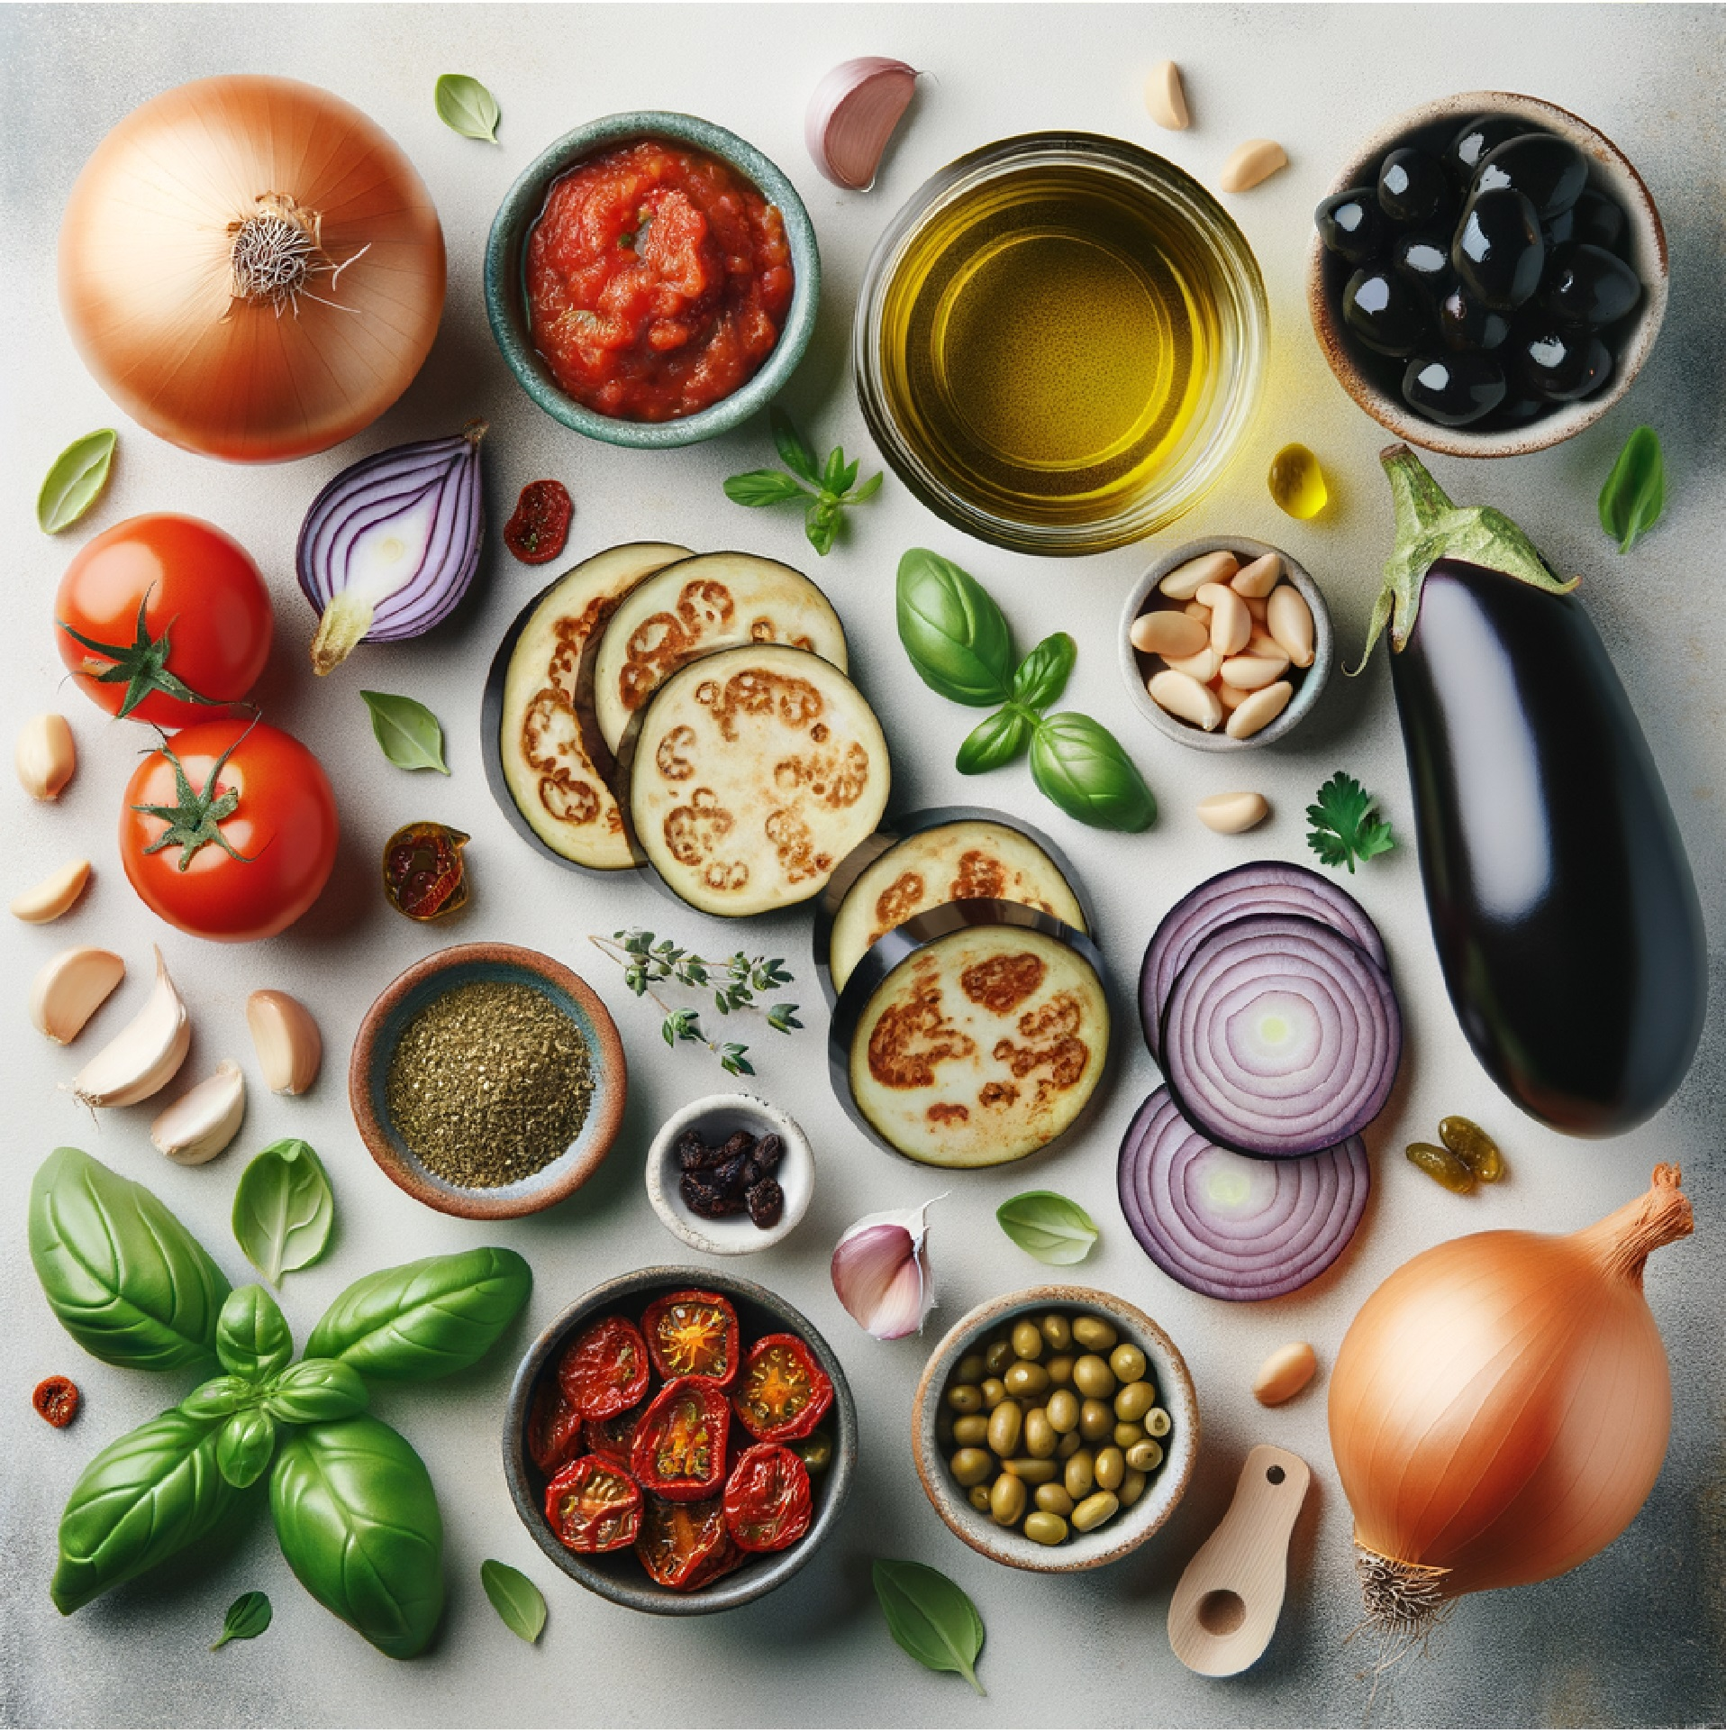
- 1 (14–15 oz) can crushed tomatoes
- 1 onion, diced
- 4 cloves garlic, minced
- ½ cup kalamata olives, pitted & sliced
- ¼ cup sun-dried tomatoes, chopped
- 2 tbsp capers, drained
- ¼ cup fresh basil, chiffonade
- 2 tbsp fresh oregano, chopped (or 1 tsp dried)
- ¼ cup pine nuts
- ¼ cup olive oil (divided)
- Balsamic vinegar, for drizzling
- Salt & black pepper, to taste
- Optional: pinch red pepper flakes

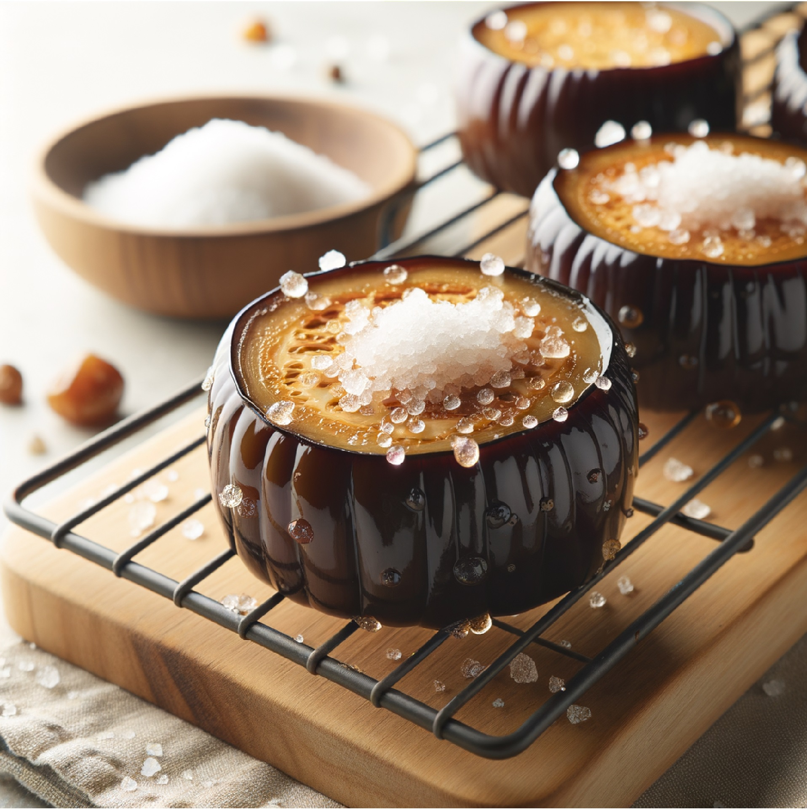

1) Prep & Salt the Eggplant (30 min)
- Lay the ½-inch rounds on racks or paper towels.
- Sprinkle evenly with kosher salt (about 1 tsp per large eggplant).
- Rest 30 minutes until moisture beads form.
- Rinse briefly, then pat completely dry.

2) Toast the Pine Nuts (3–4 min)
- Dry-toast ¼ cup pine nuts in a small skillet over medium heat, stirring until golden and fragrant.
- Transfer to a plate immediately to avoid overbrowning.

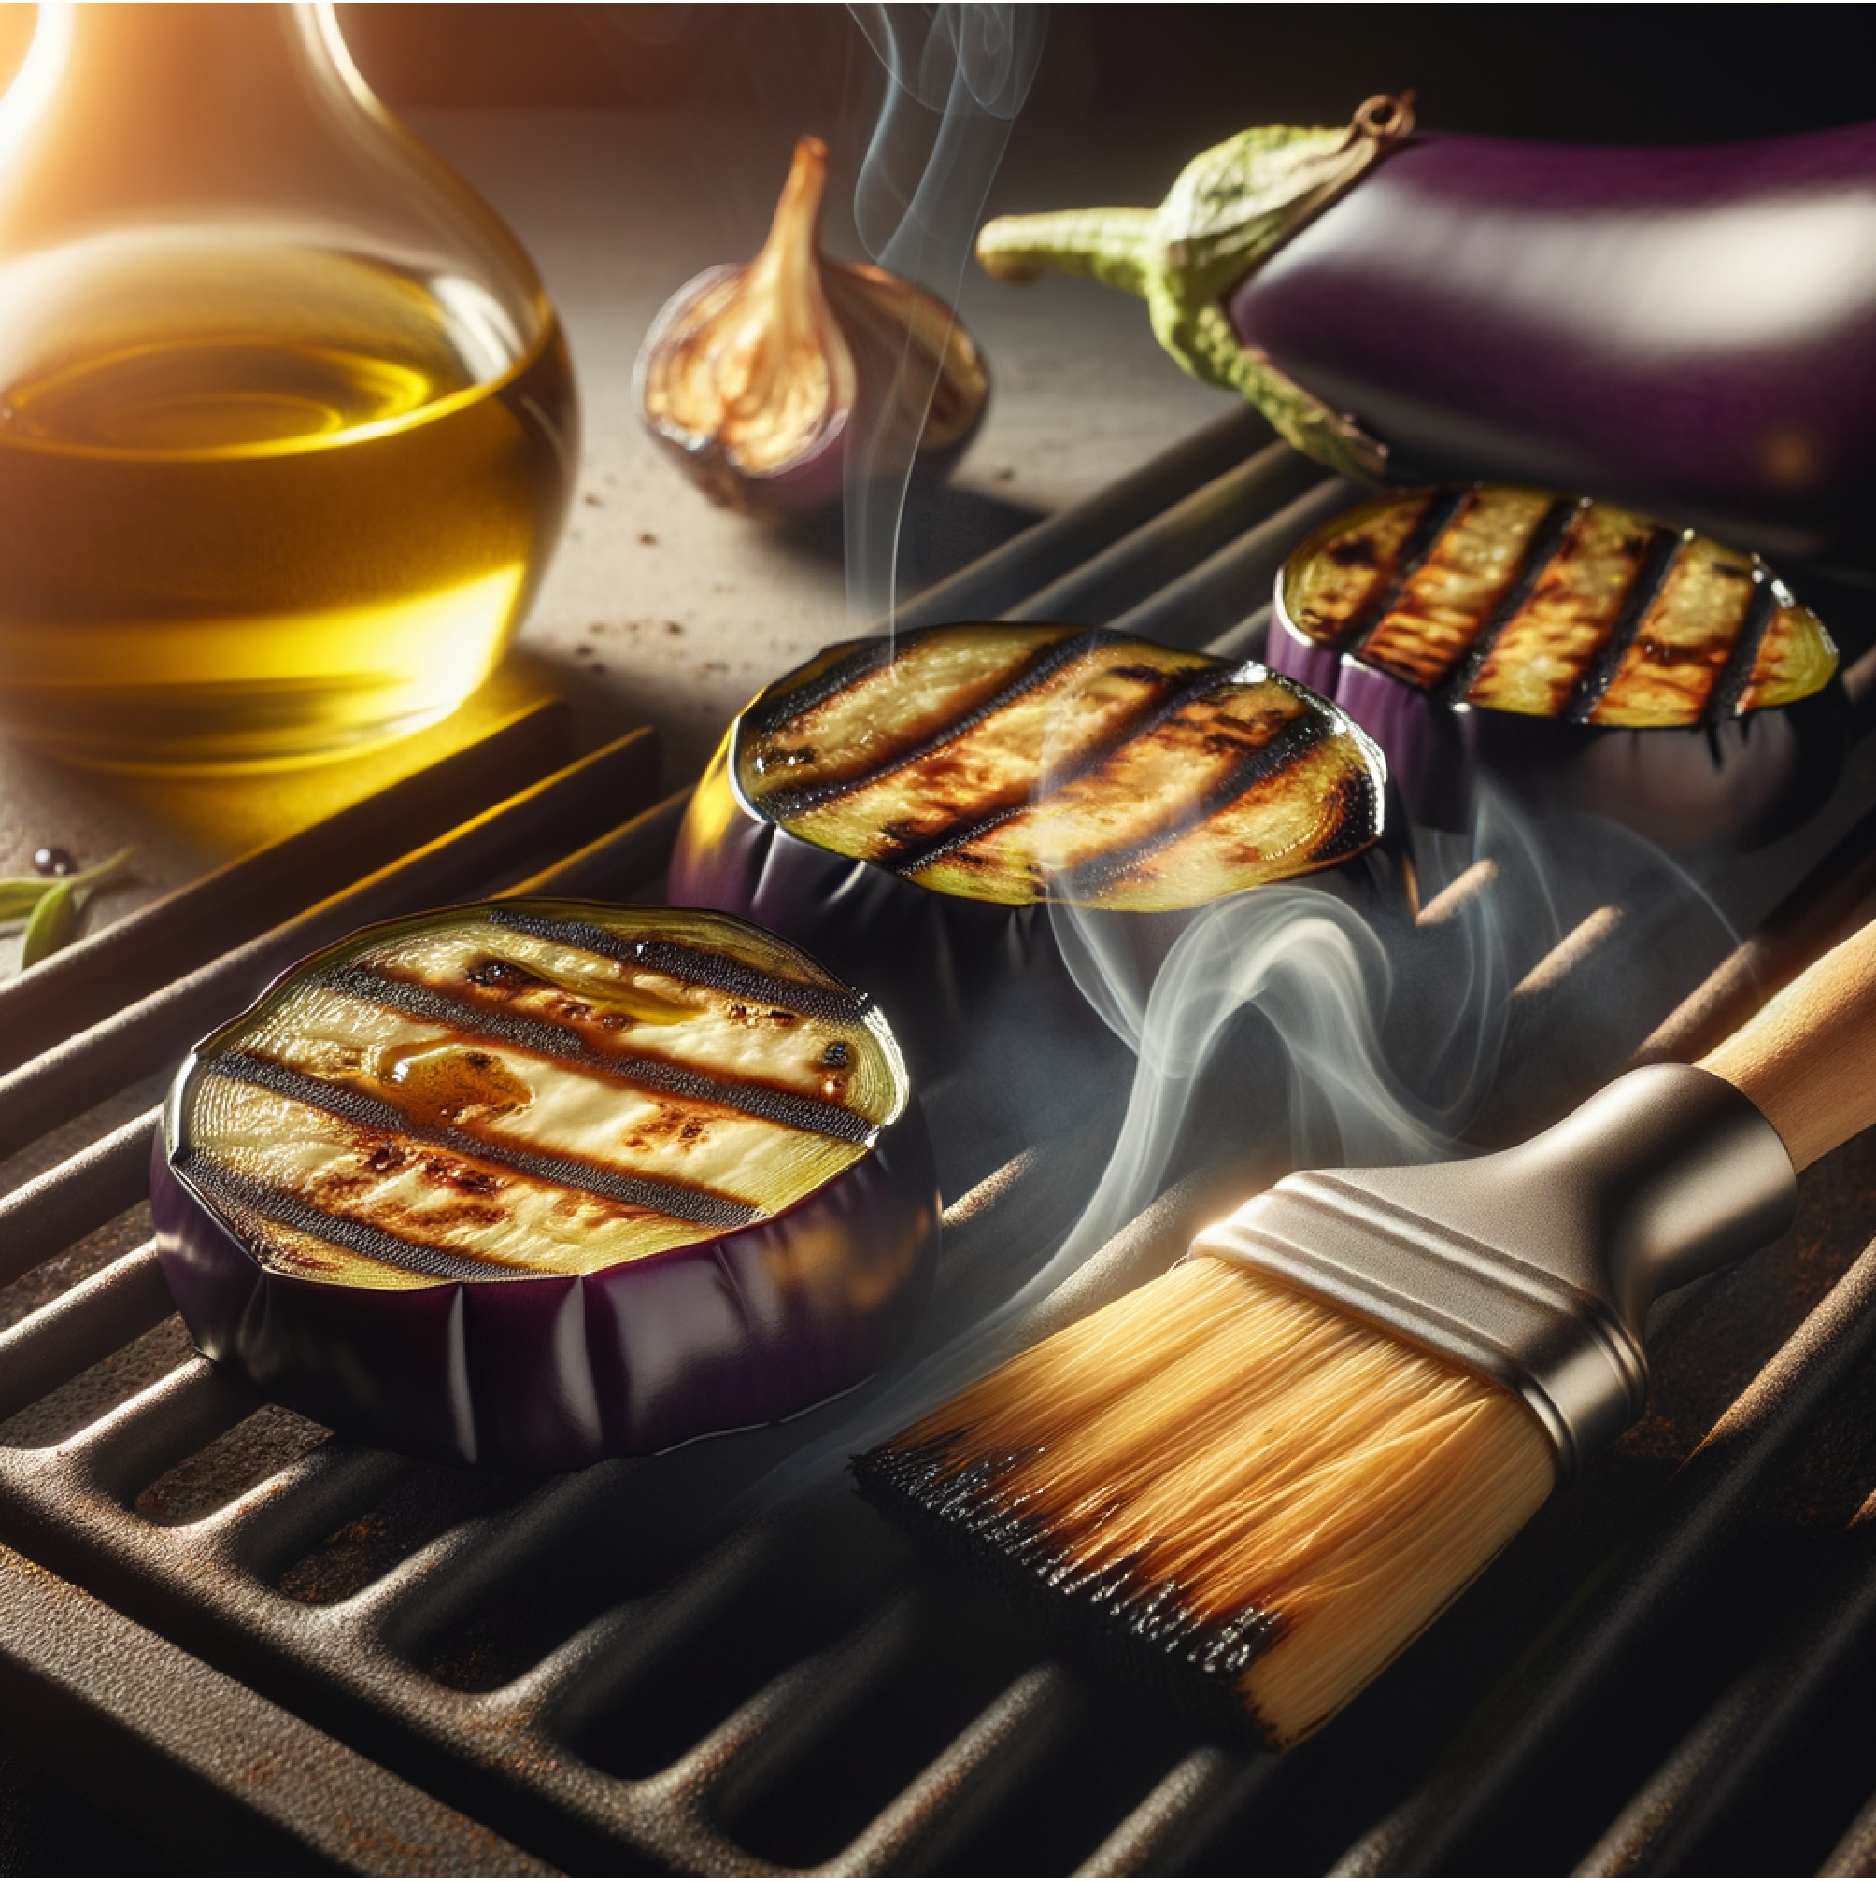
3) Grill/Roast the Eggplant
Grill: Brush both sides with olive oil, season with pepper. Grill over medium-high heat 3–4 min per side until tender with clear grill marks.
Oven option: Arrange on oiled sheet, brush tops with oil. Roast at 425°F (220°C) 20–25 min, flipping halfway, until soft and lightly browned.

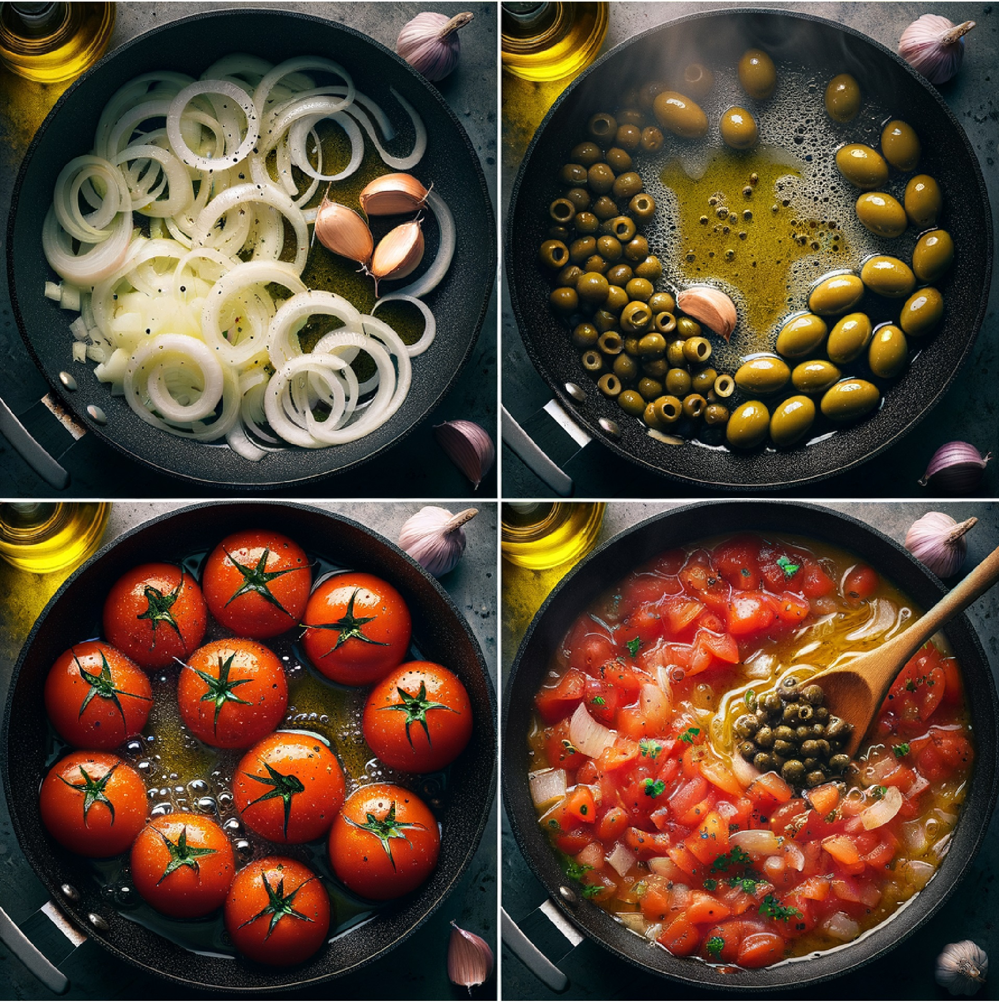
4) Make the Saucy Topper (12–15 min)
- In a wide skillet, heat 2 tbsp olive oil over medium.
- Sauté diced onion with a pinch of salt 5–7 min until translucent and lightly golden.
- Add garlic (and red pepper flakes if using) 30–60 sec until fragrant.
- Stir in crushed tomatoes, sun-dried tomatoes, olives, capers, oregano.
- Simmer 12–15 min until thickened and glossy.
- Taste; season with salt & pepper. Add a splash of olive oil for sheen if desired.

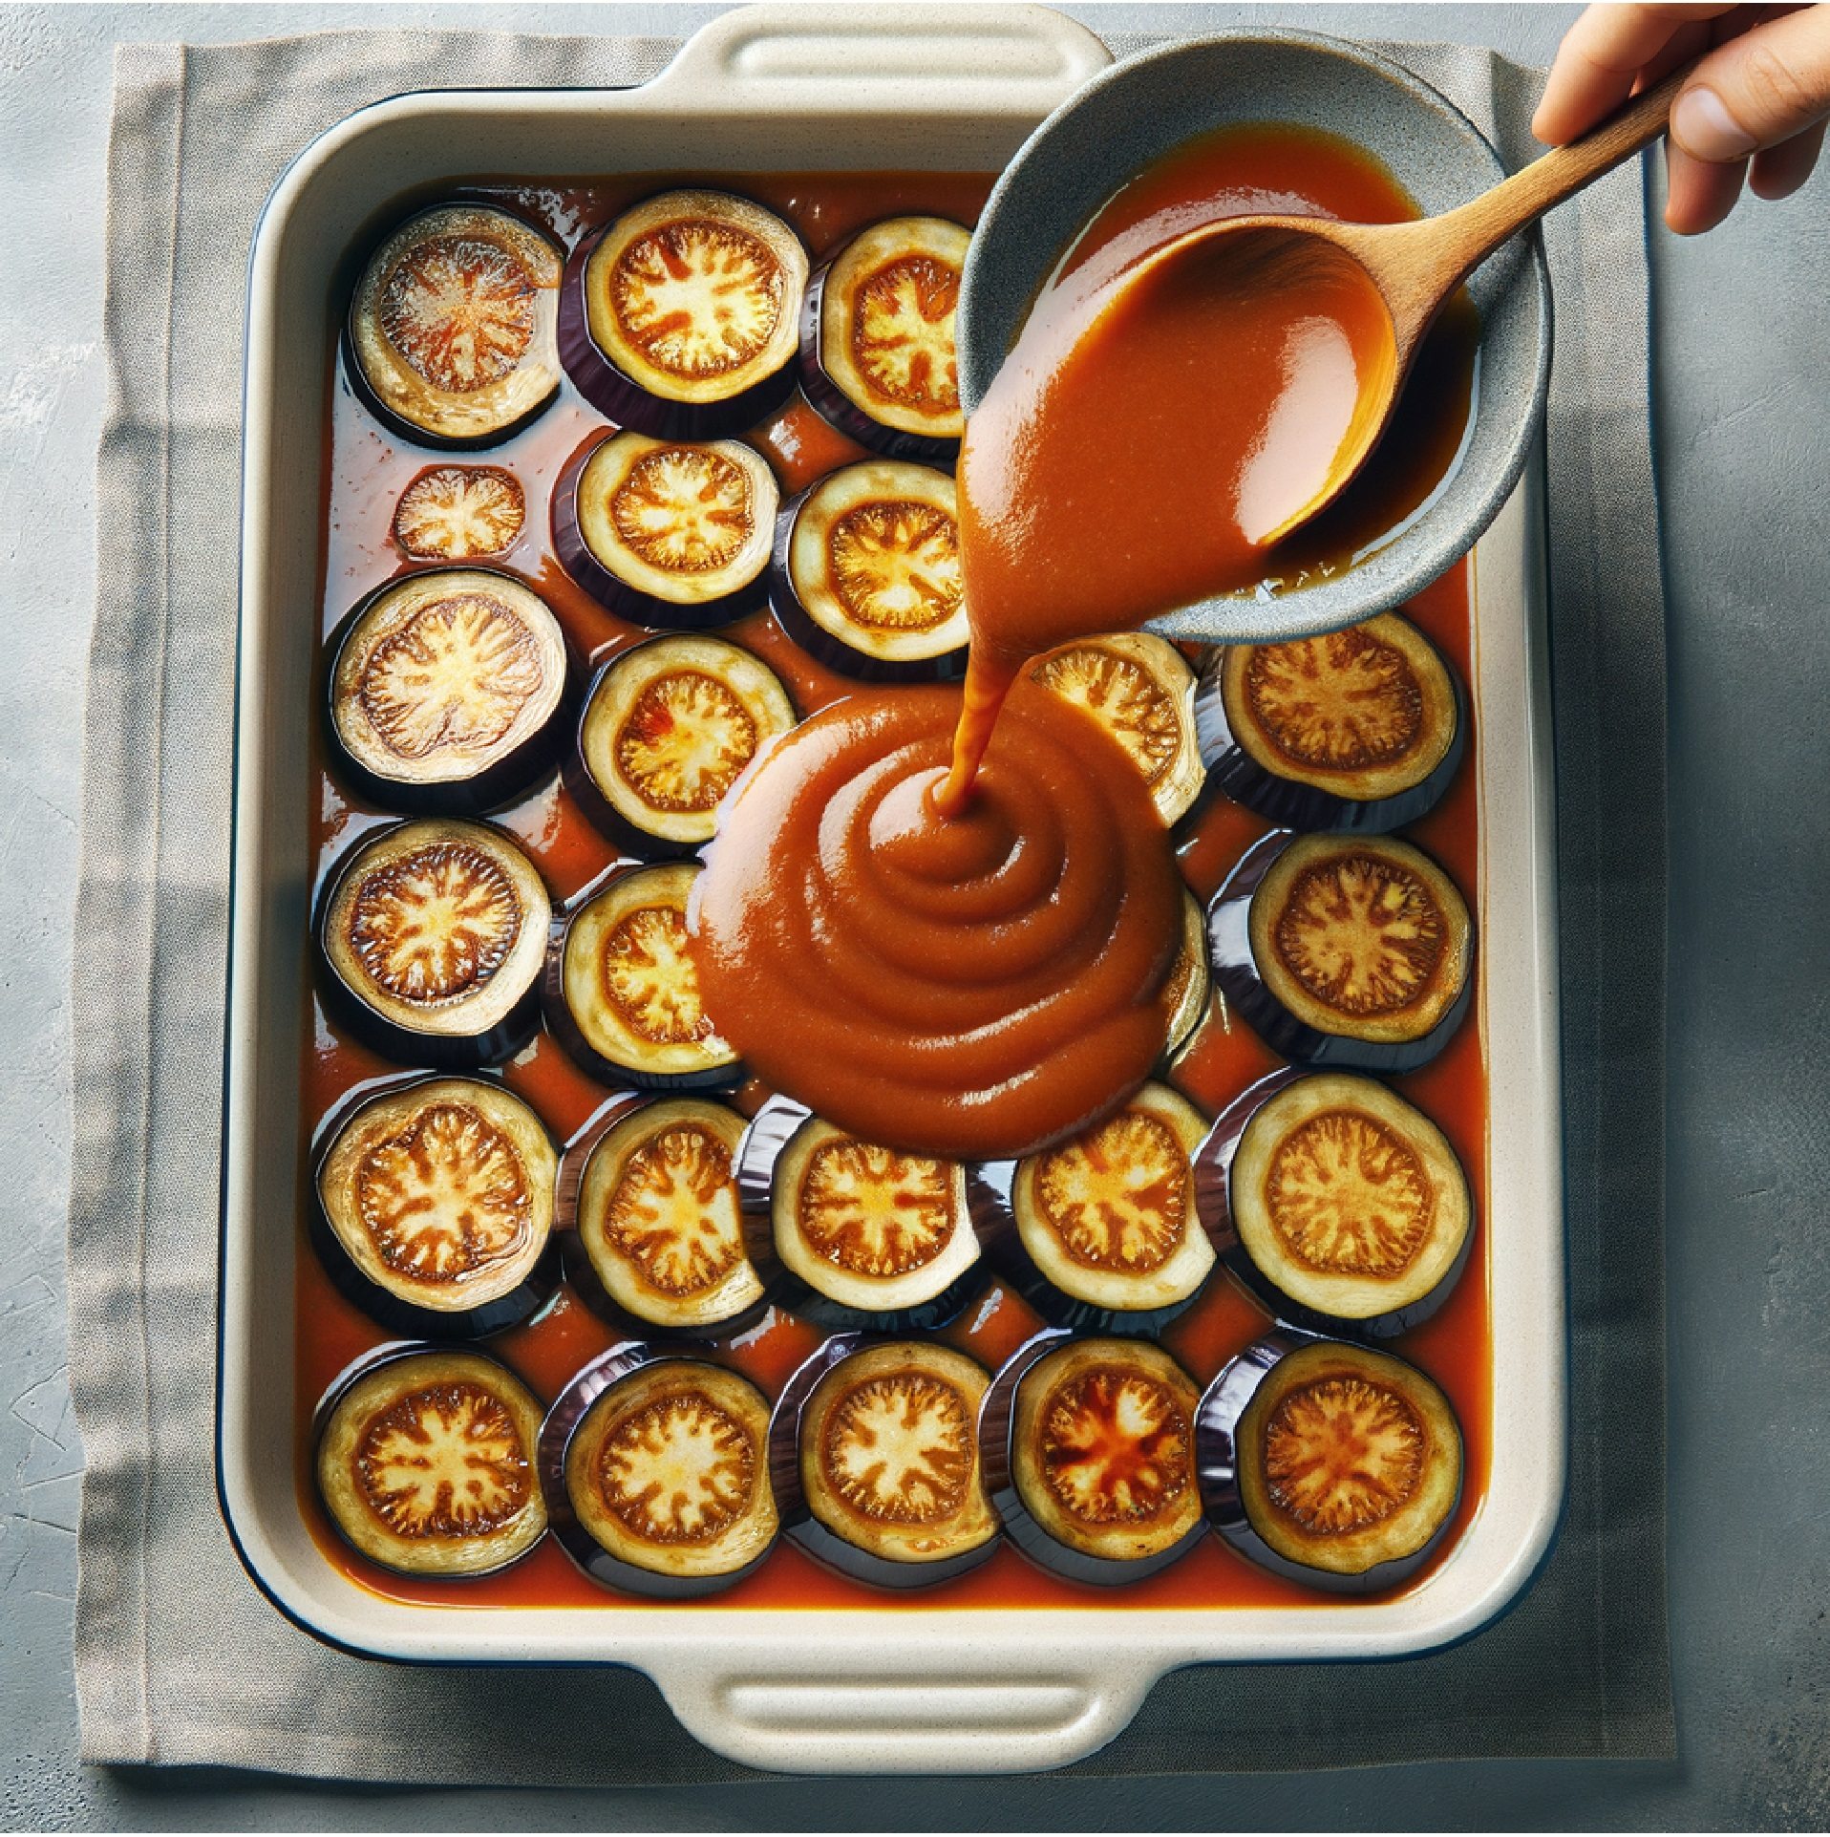
5) Layer & Warm Through (5–10 min)
- In a shallow baking dish or serving platter, overlap a layer of eggplant, spoon on some sauce; repeat to use everything, finishing with sauce on top.
- To meld flavors, place in a 350°F (175°C) oven 5–10 min (optional), or rest covered 5 min off heat.

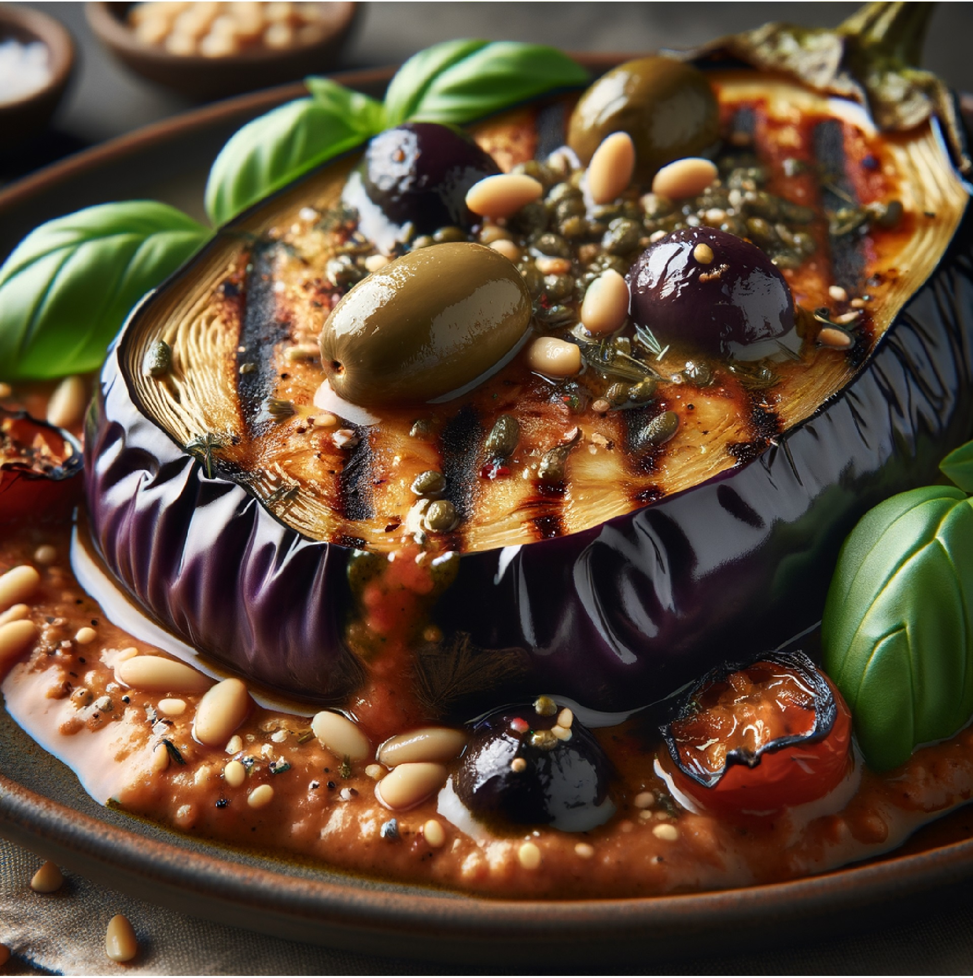
6) Finish & Serve
- Sprinkle with basil chiffonade and the toasted pine nuts.
- Drizzle balsamic lightly (start with 1–2 tsp).
- Add a final thread of extra-virgin olive oil.
- Serve with crusty bread, herbed couscous, or polenta.

Tips & Variations
- Substitutions: Swap in zucchini rounds; add roasted red peppers; use thyme/rosemary for a woodsy vibe.
- Make-ahead: Grill eggplant and cook sauce up to 2 days ahead; combine and warm before serving.
- Leftovers: Refrigerate 3–4 days; reheat gently. Great as a warm sandwich filling or tossed with pasta.
♻️ Substitutions: Use zucchini instead of eggplant, try different herbs like thyme or rosemary, or add roasted red peppers for extra flavor.

Fun Facts 🍆🇬🇷
- Eggplant is a berry. Botanically, it’s a fruit in the nightshade family, which is why it becomes silky and jammy when cooked.
- Salting = better texture. Salting draws out moisture, helping eggplant sear instead of steam and reducing bitterness in older/larger fruit.
- Capers are flower buds. These tangy pops are pickled buds from the caper bush—perfect for brightening rich dishes.
- Sun-dried tomatoes are flavor concentrators. Drying intensifies umami and boosts lycopene availability.
- Kalamata olives + extra-virgin olive oil bring heart-healthy monounsaturated fats and deep, savory notes.
- Toasting pine nuts unlocks buttery aroma and adds crunchy contrast to the silky eggplant.
- Mediterranean herbs (basil, oregano) carry aromatic oils that bloom in warm oil, lifting the whole dish.

🧠 Antioxidant Power: Eggplant contains nasunin, a powerful antioxidant that protects brain cells from damage. The purple skin is where most of these beneficial compounds are found.

Nutrient | Amount | % Daily Value*
Calories | 285 | —
Protein | 8 g | —
Carbohydrates | 32 g | —
Fat | 16 g | —
Fiber | 12 g | —
Vitamin K | — | 25%
Folate | — | 20%
Potassium | — | 25%

*%DV based on a 2,000-calorie diet.

